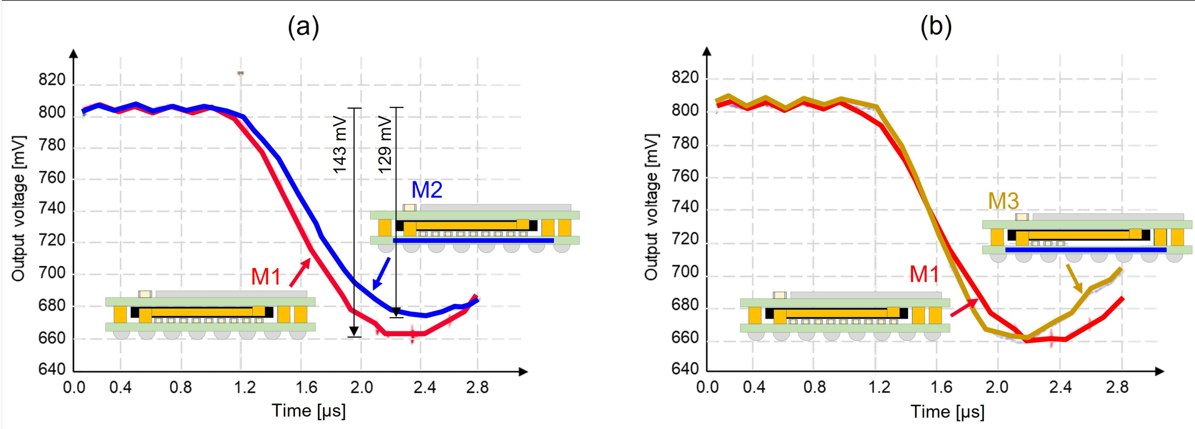

New DC-DC Converter Module for High-Performance Computing: Voltage-droop is a growing problem as more components are integrated into advanced packages. Murata researchers will describe a novel DC-DC converter module that addresses the issue for high-performance computing (HPC) applications and vertical power delivery packaging architectures. The module has a low profile, good transient response and high efficiency. It makes use of an advanced low-impedance substrate the researchers call integrated Package Solution (iPaS), which has embedded capacitors that are specialized for power delivery. The researchers demonstrated its performance with modules ≤5 mm in height, which is low enough to be mounted on the backside of the motherboard of an accelerator card for HPC. Using the low-impedance iPaS substrate (1 mΩ @ 1 MHz), nearly the same voltage-droop was achieved vs. that of a general module, even with a >60% reduction of SMD-type capacitors. When the number of SMD capacitors was not reduced, the voltage droop improved by 14 mV (10 %), demonstrating that the technology will be an effective solution for improving the transient response of power supply modules. Power supply efficiency was further improved by more than two points when the researchers added inductors to the space created by reducing the number of SMD-type capacitors. They researchers say this novel technology will be a solution for power supply issues for the next generation of HPC.

The graphs above show the effect of the iPaS substrate on module performance. Several different modules with different bottom substrates were assembled for transient response comparisons:
- Graph (a) above compares the voltage-droop results of the M1 module (conventional substrate) and M2 module (iPaS substrate). A significant voltage-droop improvement of about 14 mV (10%) can be seen.
- In graph (b), the M3 module uses an iPaS substrate with a reduced capacitance, such that the total capacitance of its capacitor array is equivalent to the M1 module. Nearly the same voltage-droop as M1 is seen.

(Paper 25.7, “A Novel DC-DC Converter Module Using the integrated Package Solution (iPaS) Substrate for Next-Generation High-Performance Computing (HPC) Applications,” S. Yamada et al, Murata)

